CHANAKYA UNIVERSITY
SCHOOL OF ENGINEERING


ASSIGNMENT TITLE: CHANAKYA UNIVERSITY DIGITAL PATH FINDER
ASSIGNMENT -1

SUBMITTED BY:
Mallikarjun
REGISTER NO:24UG00518

SEMESTER III (ODD)
SUBJECT: INTRODUCTION TO AIML
SECTION B

ABSTRACT
The Bot Brain project aims to develop a smart digital navigation assistant for Chanakya University. The system models campus navigation as a weighted graph, where the buildings are modelled as nodes and the paths that connect the buildings are modelled as edges. Bot Brain determines the best routes for users in as little time as possible using classical AI search algorithms such as Breadth-First Search (BFS), Depth-First Search (DFS), Uniform Cost Search (UCS), and A*, with heuristics based on search methodology. In addition to providing the best route, Bot Brain also provides valuable information about the buildings such as facilities, timings, and available services in relation to their use and purpose, thereby improving the overall campus experience. A primary intent of the project is to compare the various search algorithms and allow students to discover for themselves the effect of algorithm choices on performance and efficiency in real world applications. By combining navigation, access to information and analysis of algorithm, Bot Brain provides a tangible AI-based solution that enhances the campus experience, whether it is improving the accessibility, efficiency, or user friendliness of the campus for students and visitors alike.

INTRODUCTION
With its academic, residential, and recreational amenities, a university campus is like a miniature city. Long walking paths, numerous connected buildings, and a dearth of interactive navigation systems make it difficult for new students to navigate such a campus. Conventional approaches, such as static signboards or printed maps, are frequently inadequate.
By using search algorithms to find the best routes and representing the campus as a graph, artificial intelligence offers a solution. Through the use of AI agent design, the Bot Brain project provides contextual information about buildings and models intelligent navigational decision-making. The system makes use of A* for heuristic-driven efficiency, UCS for cost-aware routing, and BFS and DFS for basic search. Beyond the classroom, the project gives students practical knowledge of intelligent agents, search issues, and algorithm evaluation.

PROBLEM STATEMENT
It can be difficult for visitors and new students to find their way around Chanakya University's expansive and strange campus. They struggle with things like not knowing where buildings are, wasting time looking for offices or classrooms, needing help from others to get directions, and not having easy access to building information like services or timings. This results in ineffective orientation, stress, and delays.
An intelligent campus navigation assistant is required to address this issue, guiding users with the shortest routes, walking times, and building details to make campus exploration more efficient and easier for newcomers.

Objectives
1. To model the Chanakya University campus as a graph of buildings and weighted paths.
2. To implement and test BFS, DFS, UCS, and A* for campus navigation.
3. To compare these algorithms in terms of efficiency and accuracy.
4. To design a chatbot interface that accepts user queries in natural language.
5. To integrate FAQs and staff/facility information with the navigation system.
6. To create a system that can be extended for future academic and administrative services.

Scope
- Covers navigation within the Chanakya University campus only.
- Includes 12+ key buildings: academic blocks, library, admin block, hostel, canteen, sports complex, medical centre, etc.
- Provides shortest routes, total distance, and estimated walking times.
- Implements four search algorithms (BFS, DFS, UCS, A*).
- Delivers facility details via chatbot.
- Future scope includes integration with academic portals for personalized assistance.

Requirements
Functional Requirements:
- Graph model of the campus with buildings as nodes and paths as weighted edges.
- Implementation of BFS, DFS, UCS, and A* algorithms.
- Ability to answer navigation queries such as 'Find path from Hostel to Library'.
- Display of route, distance, and walking time.
- Support for FAQs and basic facility information.
Non-Functional Requirements:
- Accuracy: Correct and optimal routes.
- Efficiency: Fast response using optimized algorithms.
- Scalability: Extendable for new facilities and services.
- Usability: Simple text-based interface for initial version.

Literature Review
- Search Algorithms in Pathfinding: BFS guarantees the shortest path in terms of steps; DFS explores deeper routes but is inefficient; UCS guarantees the lowest-cost path; A* improves efficiency using heuristics like Euclidean distance.
- Campus Navigation Systems: Previous works have used mobile maps and QR-based navigation, but few integrate conversational agents.
- Chatbots in Education: AI chatbots have been applied for FAQs, admission support, and student engagement. Integrating them with search algorithms for navigation is an innovative application.
- Intelligent Agents: Studies on agent design show that modeling an agent’s environment, sensors, actuators, and goals (PEAS framework) is essential for building intelligent systems.

Tools & Technology List
- Programming Language: Python
- Algorithms: BFS, DFS, UCS, A* (implemented from scratch using Python data structures)
- API: Google Maps API (for real-world distance approximation)
- Libraries: NetworkX (graph modeling), Matplotlib (visualization), Numpy (math operations)
- Version Control: GitHub
- Design Tools: Figma (UI mockups), Lucidchart (architecture diagrams)
- IDE: VS Code

CAMPUS LAYOUT
- Main Gate
- Exit Gate
- Admin Block
- Academic Block
- Library
- Canteen
- Hostel
- Mart
- Food Court
- Sports Ground
- Auditorium
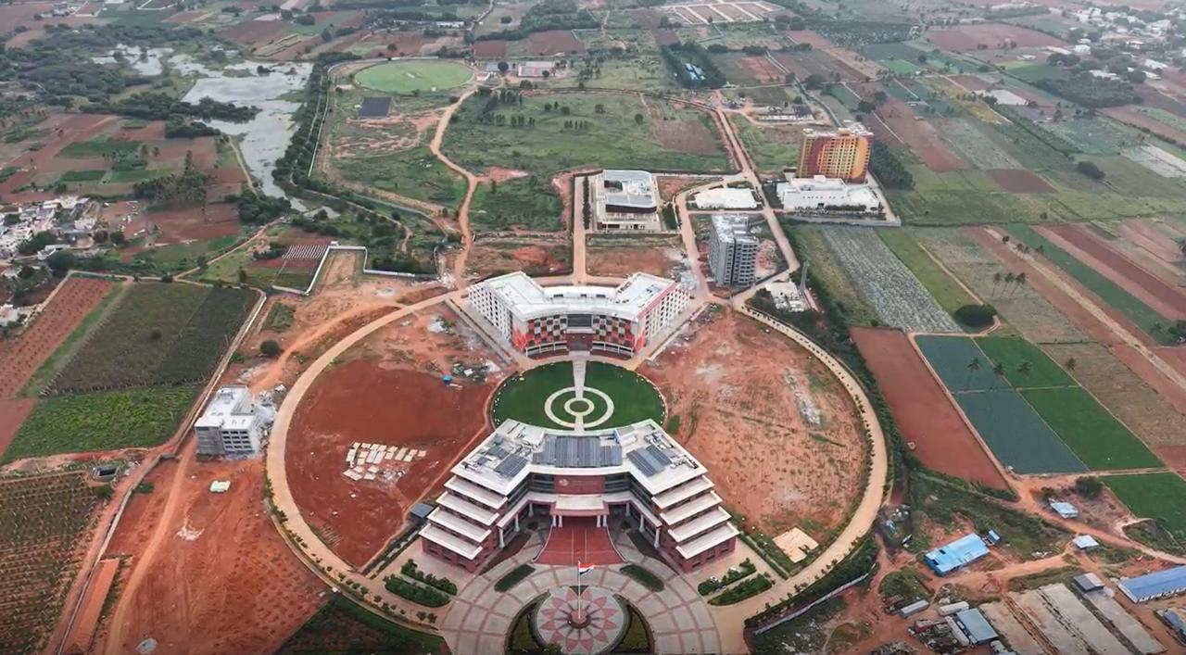
- Medical Facility

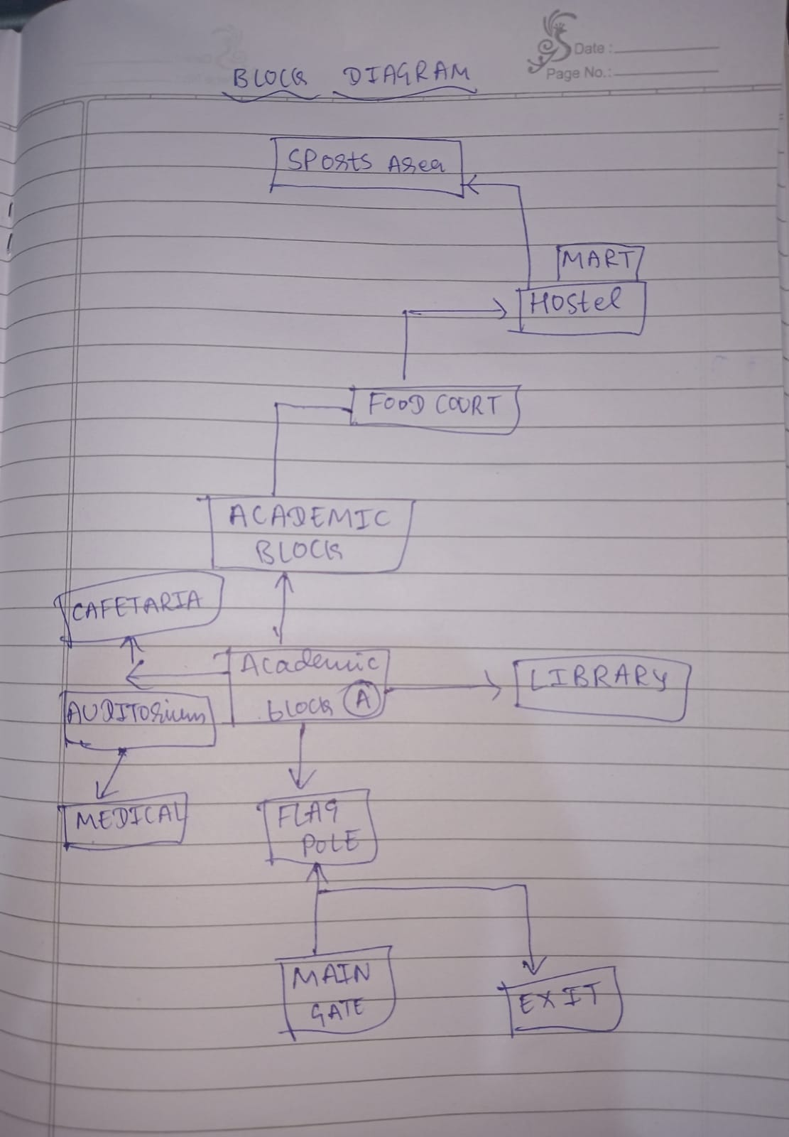

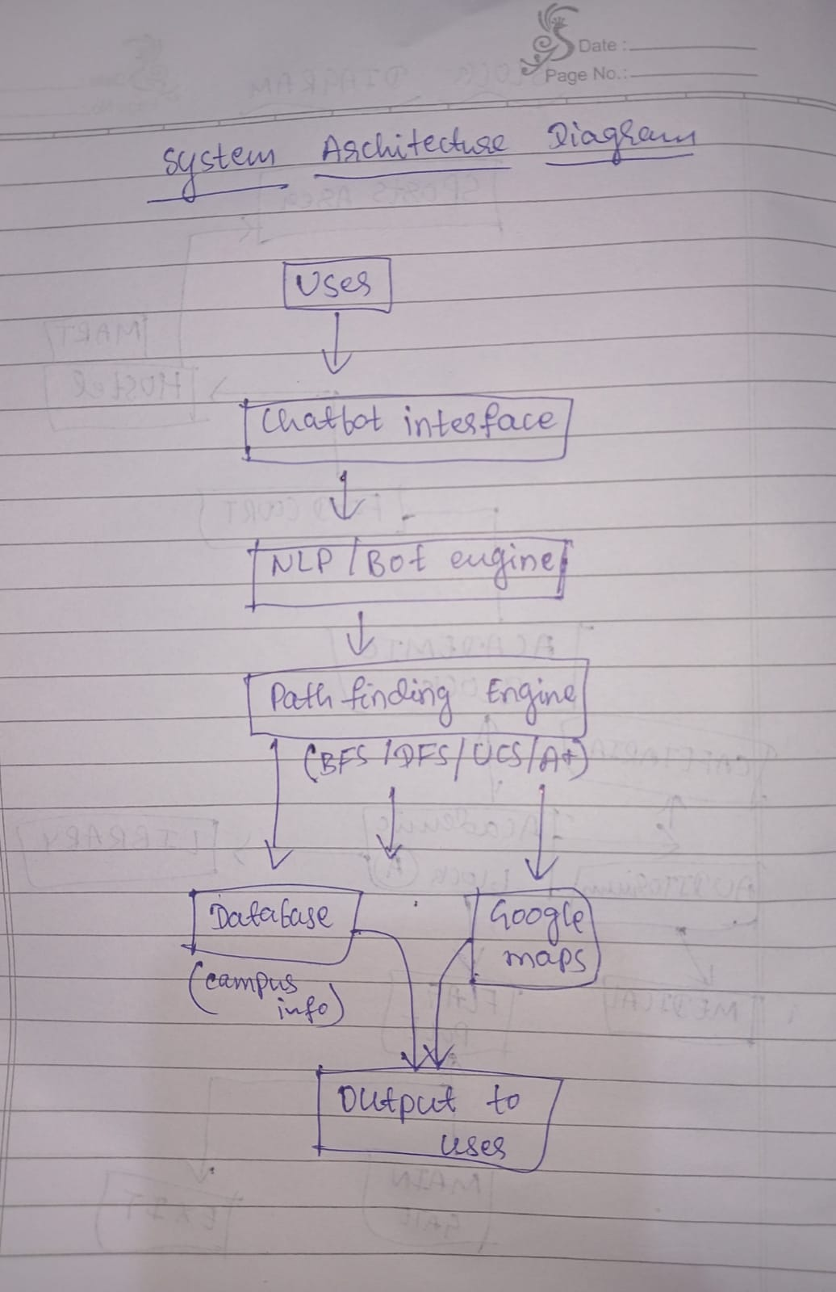
- System Architecture Diagram
The architecture is designed with a modular flow: User → Chatbot UI → NLP & Bot Engine → Navigation/Pathfinding → Database Explanation: User asks a question. Chatbot UI receives it. NLP engine interprets meaning. Pathfinding engine (BFS, DFS, UCS, A*) solves navigation queries. Database provides FAQs, staff info, or building details.
- Modules & Features User Interface (UI):
User interacts via chatbot (console/text). NLP & Bot Engine: Identifies query type (pathfinding, FAQ, staff info). Navigation/Pathfinding: Algorithms BFS, DFS, UCS, A* provide routes. Database: Stores building details, staff info, FAQs (can start with Python dictionaries).
- Database Schema Design Locations Table:
location_id, name, description, timings. Paths Table: path_id, source, destination, distance. Staff Table: staff_id, name, department, office_location, contact. FAQs Table: faq_id, question, answer. Even if not fully implemented, showing schema proves system planning.
- Methodology
Modeled the campus as a graph (nodes = places, edges = paths). Implemented BFS, DFS, UCS, A* for navigation. Designed modular architecture (UI, NLP, Pathfinding, DB). Created database schema for structured storage. Tested with sample queries like “Find path from Library to Hostel”.
- Sample Pathfinding Example Query:
Find path from Library to Hostel. Path found: Library → Student Center → Hostel Distances: Library → Student Center Student Center → Hostel This shows BFS, DFS, UCS, and A* work for campus navigation.

Campus Path Navigator

- Chatbot / GUI Development-
Built a desktop-based interface using Tkinter (Python GUI toolkit).- Designed dropdown menus for selecting start and destination points.- Added options for selecting staff departments to search relevant contacts.- Implemented an output box to display results clearly.
- Pathfinding Algorithm Integration-
BFS (Breadth First Search): Finds shortest path in terms of hops. –
DFS (Depth First Search): Explores deeper paths first.
- UCS (Uniform Cost Search): Guarantees shortest path by distance.
- A* Search Algorithm: Framework added for heuristic-based navigation (currently heuristic = 0, can be improved later). Each algorithm returns both the path (sequence of locations) and the distance (in meters).
3. Campus Distance Data
- Created a distance dictionary storing distances (in meters) between major campus locations such as: Admin Block, Academic Block, Library, Cafeteria, Auditorium, Hostel, Medical, Mini Mart, Sports Complex, etc.- Used this dataset as input for the pathfinding algorithms.
4. Staff Contact Database Integration
- Implemented a structured dictionary for department-wise staff contacts (Admin, Academic, Library, Hostel, Sports, Medical, etc.).- Added search functionality to fetch and display staff names with phone numbers dynamically.
5. Prototype Demonstration
- User can:- Select a start and end location → Get navigation path & distance using chosen algorithm.- Select a department → Retrieve staff details instantly. - Output is displayed in a text area for easy readability

CODE

import tkinter as tk
from tkinter import ttk, messagebox
from collections import deque
import heapq
import webbrowser

# ----------------------------
# DISTANCES DATA (meters)
# ----------------------------
distances = {
"Admin Block": {
"Security Entrance": 80, "Library": 16, "Auditorium": 17, "Academic Block": 126,
"Cafeteria": 35, "Main Gate": 160, "Exit Gate": 220, "Medical": 80,
"Hostel": 506, "Mini Mart": 434, "Food Court": 355, "Sports": 850
},
"Academic Block": {
"Security Entrance": 240, "Library": 46, "Auditorium": 150, "Cafeteria": 27,
"Main Gate": 210, "Exit Gate": 250, "Medical": 85, "Hostel": 380,
"Mini Mart": 410, "Food Court": 192, "Admin Block": 126, "Sports": 561
},
"Library": {
"Security Entrance": 100, "Auditorium": 3, "Academic Block": 46, "Cafeteria": 63,
"Main Gate": 275, "Exit Gate": 240, "Medical": 75, "Hostel": 450,
"Mini Mart": 465, "Food Court": 470, "Admin Block": 16, "Sports": 857
},
"Cafeteria": {
"Security Entrance": 130, "Library": 63, "Auditorium": 10, "Academic Block": 27,
"Main Gate": 276, "Exit Gate": 270, "Medical": 90, "Hostel": 520,
"Mini Mart": 585, "Food Court": 355, "Admin Block": 35, "Sports": 920
},
"Auditorium": {
"Security Entrance": 120, "Library": 3, "Academic Block": 150, "Cafeteria": 10,
"Main Gate": 286, "Exit Gate": 260, "Medical": 80, "Hostel": 510,
"Mini Mart": 574, "Food Court": 344, "Admin Block": 17, "Sports": 930
}
}

# ----------------------------
# STAFF CONTACTS
# ----------------------------
contacts = {
"Admin": {
"Admission": [{"name": "Thanushree", "phone": "08031233133"},
{"name": "Sri Vijay Kumar", "phone": "08031233103"}],
"Registrar": [{"name": "Sri Gautam", "phone": "08031233104"},
{"name": "Sri Dhanashri", "phone": "08031233101"}],
"Communication": {"name": "Sri Chandrashekar", "phone": "08031233107"},
"Finance": {"name": "Sri Sudheerda K.M", "phone": "08031233102"},
"IT Support": {"name": "Sri Sachin Goni", "phone": "08031233109"}
},
"Academic": {
"VC Office": [
{"name": "Shilparanganathra", "phone": "08031233122"},
{"name": "Ashwin Kumar", "phone": "Contact VC Office"},
{"name": "Subhant T. Joshi", "phone": "08031233104"},
{"name": "Dr. Padmavathi B.S", "phone": "Contact VC Office"},
{"name": "Dr. Vineeth Paleni", "phone": "Contact VC Office"}
]
},
"Library": {"name": "Bharathkumar V", "phone": "8861775721"},
"Medical Center": {"name": "Dr. Anjana", "phone": "08031233103"},
"Sports & P.E": {"name": "Sri Hemanth", "phone": "9449141869"},
"Hostel": {
"Girls": {"name": "Jayshree", "phone": "9513228510"},
"Boys": {"name": "Ullas Kallur", "phone": "08031233100"}
}
}

# ----------------------------
# PATHFINDING ALGORITHMS
# ----------------------------
def bfs(start, goal):
queue = deque([(start, [start], 0)])
visited = set()
while queue:
node, path, dist = queue.popleft()
if node == goal:
return path, dist
if node not in visited:
visited.add(node)
for nbr, d in distances.get(node, {}).items():
if nbr not in visited:
queue.append((nbr, path + [nbr], dist + d))
return None, None

def dfs(start, goal):
stack = [(start, [start], 0)]
visited = set()
while stack:
node, path, dist = stack.pop()
if node == goal:
return path, dist
if node not in visited:
visited.add(node)
for nbr, d in distances.get(node, {}).items():
if nbr not in visited:
stack.append((nbr, path + [nbr], dist + d))
return None, None

def ucs(start, goal):
queue = [(0, start, [start])]
visited = set()
while queue:
cost, node, path = heapq.heappop(queue)
if node == goal:
return path, cost
if node not in visited:
visited.add(node)
for nbr, d in distances.get(node, {}).items():
if nbr not in visited:
heapq.heappush(queue, (cost + d, nbr, path + [nbr]))
return None, None

def heuristic(a, b):
return 0

def a_star(start, goal):
queue = [(0, 0, start, [start])]
visited = set()
while queue:
est, cost, node, path = heapq.heappop(queue)
if node == goal:
return path, cost
if node not in visited:
visited.add(node)
for nbr, d in distances.get(node, {}).items():
if nbr not in visited:
new_cost = cost + d
est_total = new_cost + heuristic(nbr, goal)
heapq.heappush(queue, (est_total, new_cost, nbr, path + [nbr]))
return None, None

# ----------------------------
# CHATBOT RESPONSES (keywords)
# ----------------------------
# mapping of keyword sets to reply strings
chatbot_knowledge = {
("library", "where is library", "library timings"): "The Library is near the Auditorium and Admin Block. Timings: 8AM-10PM.",
("vc", "vice chancellor", "who is vc", "vc office"): "The VC’s office is in Academic Block. Contact: Shilparanganathra (08031233122).",
("hostel", "hostel contact"): "Hostel contacts - Girls: Jayshree (9513228510); Boys: Ullas Kallur (08031233100).",
("medical", "medical center", "doctor"): "Medical Center: Dr. Anjana (08031233103).",
("sports", "sports pe", "sports & p.e"): "Sports & P.E: Sri Hemanth (9449141869).",
("admission", "how to apply", "admission contact"): "Admission: Thanushree (08031233133), Sri Vijay Kumar (08031233103).",
("map", "campus map", "open map"): "Click the 'Open Campus Map' button to view Chanakya University's map.",
("hello", "hi", "hey"): "Hello! I am the Chanakya University assistant. Ask me about locations, staff, or distances.",
("thanks", "thank you"): "You're welcome! Anything else I can help with?"
}

def chatbot_lookup(user_text):
text = user_text.lower()
# exact keyword contains check
for keys, resp in chatbot_knowledge.items():
for key in keys:
if key in text:
return resp
# fallback: try to answer simple distance question "how far from X to Y"
if "how far" in text or "distance" in text:
# try to parse "from <A> to <B>" or "between <A> and <B>"
words = text.replace("?", "").split()
if "from" in words and "to" in words:
try:
i = words.index("from")
a = words[i+1]
j = words.index("to")
b = words[j+1]
# try to match keys loosely by capitalizing and matching start
a_match = next((k for k in distances.keys() if k.lower().startswith(a)), None)
b_match = next((k for k in distances.keys() if k.lower().startswith(b)), None)
if a_match and b_match and b_match in distances.get(a_match, {}):
return f"Distance from {a_match} to {b_match} is {distances[a_match][b_match]} meters."
except Exception:
pass
return "Sorry, I don't know that yet. Try asking about library, VC, hostel, medical, sports, admission, or 'map'."

# ----------------------------
# UI ACTIONS
# ----------------------------
def find_path(algo):
start = start_var.get()
end = end_var.get()
if not start or not end:
messagebox.showwarning("Input Error", "Please select both start and destination.")
return
if start == end:
messagebox.showinfo("Result", "You are already at the destination.")
return

if algo == "BFS":
path, dist = bfs(start, end)
elif algo == "DFS":
path, dist = dfs(start, end)
elif algo == "UCS":
path, dist = ucs(start, end)
else:
path, dist = a_star(start, end)

if path:
out = f"{algo}: {' → '.join(path)} | Distance: {dist} meters"
else:
out = f"{algo}: No path found"
output_box.insert(tk.END, out + "\n")
output_box.see(tk.END)

def search_staff():
dept = staff_var.get()
if not dept:
messagebox.showwarning("Input Error", "Please select a department/area.")
return
info = contacts.get(dept, None)
output_box.insert(tk.END, f"--- {dept} Contacts ---\n")
if isinstance(info, dict):
for key, value in info.items():
if isinstance(value, list):
for person in value:
output_box.insert(tk.END, f"{key}: {person['name']} - {person['phone']}\n")
elif isinstance(value, dict):
output_box.insert(tk.END, f"{key}: {value['name']} - {value['phone']}\n")
else:
output_box.insert(tk.END, f"{key}: {value}\n")
elif isinstance(info, list):
for person in info:
output_box.insert(tk.END, f"{person['name']} - {person['phone']}\n")
else:
output_box.insert(tk.END, "No contacts found.\n")
output_box.insert(tk.END, "\n")
output_box.see(tk.END)

def open_map():
html = """
<!DOCTYPE html>
<html>
<head>
<title>Chanakya University Map</title>
<meta charset="utf-8" />
<meta name="viewport" content="width=device-width, initial-scale=1.0">
<link rel="stylesheet" href="https://unpkg.com/leaflet/dist/leaflet.css"/>
<script src="https://unpkg.com/leaflet/dist/leaflet.js"></script>
</head>
<body style="margin:0;">
<div id="map" style="width: 100%; height: 100vh;"></div>
<script>
var map = L.map('map').setView([13.1976, 77.7066], 16);
L.tileLayer('https://{s}.tile.openstreetmap.org/{z}/{x}/{y}.png', {
maxZoom: 19
}).addTo(map);
// Add a basic marker for Chanakya University
L.marker([13.1976, 77.7066]).addTo(map)
.bindPopup("<b>Chanakya University</b><br>Devanahalli").openPopup();
</script>
</body>
</html>
"""
filename = "chanakya_map.html"
with open(filename, "w", encoding="utf-8") as f:
f.write(html)
webbrowser.open(filename)

# Chatbot quick-button handlers (predefined answers)
def quick_reply(key):
text = chatbot_lookup(key)
chatbot_output_insert("You (button): " + key)
chatbot_output_insert("Bot: " + text + "\n")

def chatbot_output_insert(msg):
chatbot_output.configure(state="normal")
chatbot_output.insert(tk.END, msg + "\n")
chatbot_output.configure(state="disabled")
chatbot_output.see(tk.END)

def chatbot_ask_text():
user_text = chatbot_entry.get().strip()
if not user_text:
return
chatbot_entry.delete(0, tk.END)
chatbot_output_insert("You: " + user_text)
resp = chatbot_lookup(user_text)
chatbot_output_insert("Bot: " + resp + "\n")

# ----------------------------
# BUILD THE GUI
# ----------------------------
root = tk.Tk()
root.title("Campus Path Navigator - Chanakya University")
root.geometry("820x900")

# banner
welcome_label = tk.Label(root, text="Chanakya University Navigator",
font=("Helvetica", 18, "bold"), fg="white", bg="darkblue")
welcome_label.pack(fill="x", pady=5)

main_frame = tk.Frame(root)
main_frame.pack(padx=10, pady=10, fill="both", expand=True)

# left frame: pathfinding & staff
left = tk.Frame(main_frame)
left.pack(side="left", padx=8, pady=8, anchor="n")

ttk.Label(left, text="Start Location:").pack(anchor="w")
start_var = tk.StringVar()
ttk.Combobox(left, textvariable=start_var, values=list(distances.keys()), state="readonly").pack(fill="x")

ttk.Label(left, text="Destination:").pack(anchor="w", pady=(6,0))
end_var = tk.StringVar()
ttk.Combobox(left, textvariable=end_var, values=list(distances.keys()), state="readonly").pack(fill="x")

btns = tk.Frame(left)
btns.pack(pady=8, fill="x")
ttk.Button(btns, text="Find BFS Path", command=lambda: find_path("BFS")).grid(row=0, column=0, padx=4, pady=2)
ttk.Button(btns, text="Find DFS Path", command=lambda: find_path("DFS")).grid(row=0, column=1, padx=4, pady=2)
ttk.Button(btns, text="Find UCS Path", command=lambda: find_path("UCS")).grid(row=0, column=2, padx=4, pady=2)
ttk.Button(btns, text="Find A* Path", command=lambda: find_path("A*")).grid(row=0, column=3, padx=4, pady=2)

ttk.Button(left, text="Open Campus Map", command=open_map).pack(pady=6, fill="x")

# staff
ttk.Label(left, text="Staff Department/Area:").pack(anchor="w", pady=(10,0))
staff_var = tk.StringVar()
ttk.Combobox(left, textvariable=staff_var, values=list(contacts.keys()), state="readonly").pack(fill="x")
ttk.Button(left, text="Search Staff", command=search_staff).pack(pady=6, fill="x")

# clear output button
def clear_output():
output_box.delete("1.0", tk.END)
ttk.Button(left, text="Clear Output", command=clear_output).pack(pady=6, fill="x")

# right frame: outputs + chatbot
right = tk.Frame(main_frame)
right.pack(side="left", padx=8, pady=8, fill="both", expand=True)

# Output box (path & staff)
ttk.Label(right, text="Output:").pack(anchor="w")
output_box = tk.Text(right, height=14, width=70)
output_box.pack(padx=4, pady=4, fill="both", expand=False)

# Chatbot section
ttk.Label(right, text="Campus Chatbot:").pack(anchor="w", pady=(10,0))
chatbot_frame = tk.Frame(right)
chatbot_frame.pack(fill="both", expand=True)

chatbot_output = tk.Text(chatbot_frame, height=12, width=70, state="disabled")
chatbot_output.pack(padx=4, pady=4)

entry_frame = tk.Frame(chatbot_frame)
entry_frame.pack(fill="x", padx=4, pady=4)
chatbot_entry = ttk.Entry(entry_frame, width=60)
chatbot_entry.pack(side="left", padx=(0,4), fill="x", expand=True)
ttk.Button(entry_frame, text="Ask", command=chatbot_ask_text).pack(side="left")

# quick reply buttons (predefined phrases)
quick_btns_frame = tk.Frame(chatbot_frame)
quick_btns_frame.pack(fill="x", padx=4, pady=4)
quick_phrases = ["Hello", "Where is Library", "Who is VC", "Hostel contact", "Medical", "Sports", "Admission", "Map"]
for i, phrase in enumerate(quick_phrases):
ttk.Button(quick_btns_frame, text=phrase, command=lambda p=phrase: quick_reply(p)).grid(row=i//4, column=i%4, padx=4, pady=4, sticky="ew")

# start with a greeting
chatbot_output_insert("Bot: Hello! I can help with campus locations, staff contacts, distances, and the map. Try typing or using the quick buttons.")

# run
root.mainloop()

OUTPUT
